ART II SKETCHBOOK ASSIGNMENTS 2013-2014
SB #1: Juxtaposition Drawing: Create a new object by combining 2 unrelated objects. One needs to be from nature, the other needs to be mechanical. Render with full shading. Medium: colored pencil
SB #2: Scissor Metamorphosis: Use a pair of scissors as a beginning point. Creatively transform the scissors into something else- a monster, a robot, a machine, a vehicle, an animal. Change its scale & its purpose. Render with full shading. Medium: colored pencils
SB #3: Student Choice: Choose your own subject and complete a drawing using skills & techniques learned in class. Medium: Your Choice
SB #4: Preposterous Cross-links: Choose any 2 words below to combine together in one image:
Turtle, Octopus, Snake, Bird, Bee, Rat, Fish, Pencil, Saw, Hammer, Pliers, Scissors, Tire, Clock
Medium: colored pencil
SB #5: EXEMPLAR #1: Using Exemplar # 1, create a KWL chart in your sketchbook. In the first column, list what you already know about the artwork. In the second column, list what you’d like to know. Now do some research about the artwork. Take notes in the last column by listing the things you discover.
SB #6: Sketch something inspired by Exemplar #1! Medium: Your Choice
SB #7: Futuristic Mutation: Take an everyday object and use your imagination to redesign it with a futuristic look. Medium: colored pencils
SB #8: Wheels: Draw something with wheels (Real or imaginary). Medium: your choice
SB #9: Non-objective: Create a non-objective drawing using lines, shapes (geometric) & color-use a color scheme! Medium: Markers or colored pencils
SB #10: EXEMPLAR #2: Using Exemplar #2, create a KWL chart in your sketchbook. In the first column, list what you already know about the artwork. In the second column, list what you’d like to know. Now do some research about the artwork. Take notes in the last column by listing the things you discover.
SB #11: Sketch something inspired by Exemplar #2! Medium: Your Choice
SB #12: Hand Value Study- Draw your hand in 2 different appropriate positions (both on the same page). Render with full shading. Medium: drawing pencils
SB #13: Pet Portrait: Draw a picture of your pet or the pet you would LOVE to have. Medium: Colored Pencils
SB #14: Skateboard Deck Designs: create TWO designs for the bottom of a skateboard. You can use realistic, abstract or non-objective designs. Keep it CLEAN & appropriate. Medium: Sharpies & Markers
SB #15: EXEMPLAR #3: Using Exemplar #3, create a KWL chart in your sketchbook. In the first column, list what you already know about the artwork. In the second column, list what you’d like to know. Now do some research about the artwork. Take notes in the last column by listing the things you discover.
SB #16: Sketch something inspired by Exemplar #3! Medium: Your Choice
SB #17: Color Scheme: Choose your own subject, create an obvious focal point and complete the drawing by coloring it in a color scheme of your choice. Label what color scheme you used next to the title. Medium: Colored Pencils, Paint, or Markers
SB #18: Realistic VS Abstract: Choose one object to draw (an interesting one! NOT simple!) Divide you sketchbook page in half with a pencil line. Label at the top of one side “Realistic” & on the other side label “Abstract.” Under the Realistic side, use a pencil to draw the object as realistically as you possibly can. On the Abstract side, distort your object so that it is still somewhat recognizable-use abstracted colors to color it. Medium: Colored Pencils

SB #19: Eye Study- Find 4 different eyes in magazines. Cut them out & glue them to your sketchbook page. Draw the eyes underneath the picture & render with a FULL range of shading. Medium: pencils or colored pencils
SB #20: EXEMPLAR #4: Using Exemplar #4, create a KWL chart in your sketchbook. In the first column, list what you already know about the artwork. In the second column, list what you’d like to know. Now do some research about the artwork. Take notes in the last column by listing the things you discover.
SB #21: Sketch something inspired by Exemplar #4! Medium: Your Choice

EXEMPLAR #1:
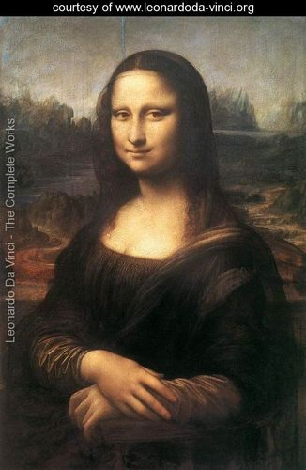

Title: “Mona Lisa”
Artist: Leonardo
Date: 1505

EXEMPLAR #2:
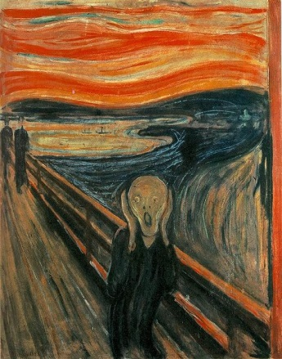

Title: “The Scream”
Artist: Edvard Munch
Date: 1893

EXEMPLAR #3:
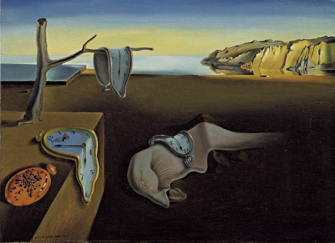

Title: “The Persistence of Memory”
Artist: Salvador Dali
Date: 1931

EXEMPLAR #4:
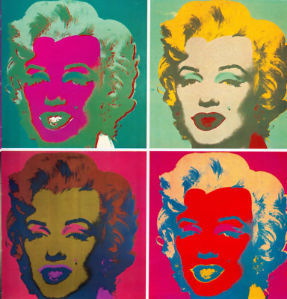

Title: “Marilyn”
Artist: Andy Warhol
Date: 1962

